

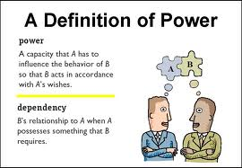

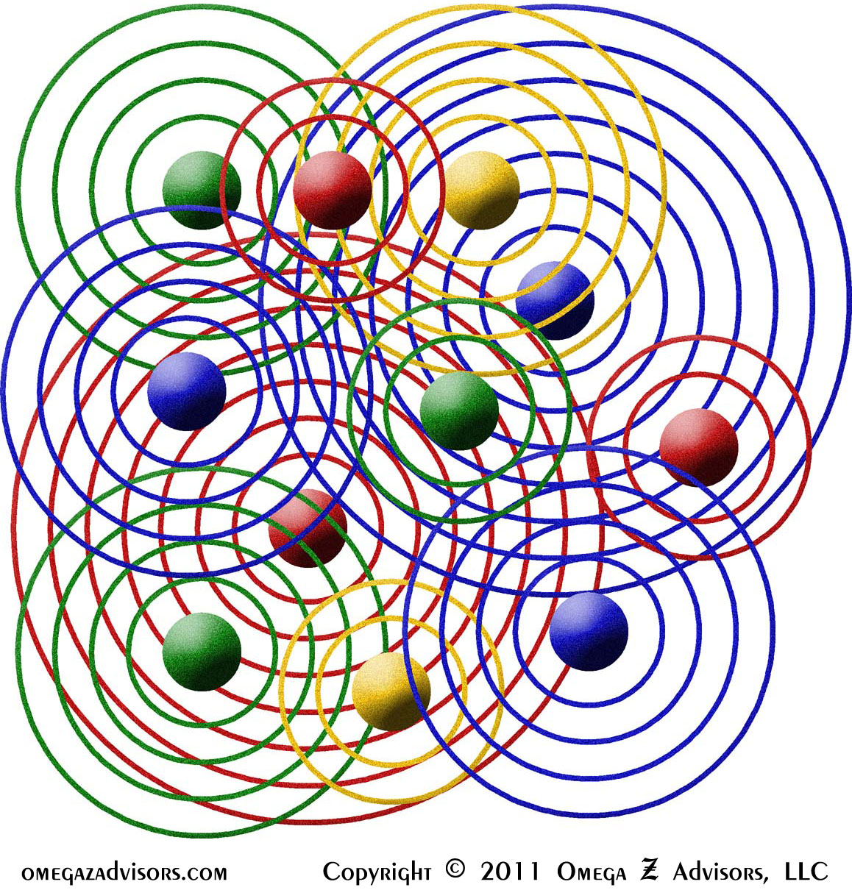

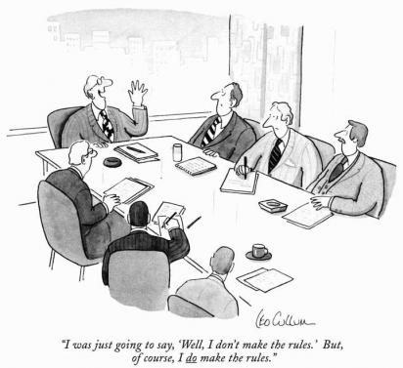



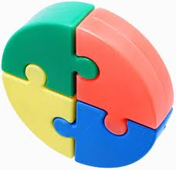 [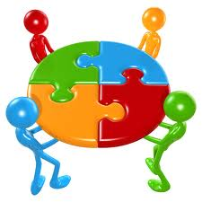](http://www.google.com/imgres?hl=en&biw=1311&bih=598&tbm=isch&tbnid=kdYO0ixavtYMiM:&imgrefurl=http://jigsawpuzzlesgames.net/&docid=yIFfBtThVO8WiM&imgurl=http://jigsawpuzzlesgames.net/wp-content/uploads/2011/05/jigsaw.jpg&w=500&h=500&ei=q05BT-eVB8TE2gWxnvSACA&zoom=1) [](http://www.google.com/imgres?hl=en&biw=1311&bih=598&tbm=isch&tbnid=ZeGWm39s3-pS_M:&imgrefurl=http://semisch11.wikispaces.com/Tale%2Bof%2BTwo%2BCities&docid=2Y2HVoGYdXarNM&imgurl=http://semisch11.wikispaces.com/file/view/jigsaw-puzzle-in_hands.jpg/103601509/jigsaw-puzzle-in_hands.jpg&w=400&h=300&ei=q05BT-eVB8TE2gWxnvSACA&zoom=1) [](http://www.google.com/imgres?hl=en&biw=1311&bih=598&tbm=isch&tbnid=y05NT_sPMhBOHM:&imgrefurl=http://www.crestock.com/image/774939-Teamwork.aspx&docid=K3xj3xvT8K-i3M&imgurl=http://images.crestock.com/770000-779999/774939-xs.jpg&w=340&h=340&ei=PE9BT-SEBYmi2gW_x6CACA&zoom=1) [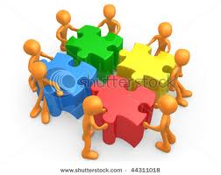](http://www.google.com/imgres?hl=en&biw=1311&bih=598&tbm=isch&tbnid=aTR2x7pIR5vjIM:&imgrefurl=http://www.shutterstock.com/pic-44311018/stock-photo--d-people-pushing-four-jigsaw-puzzle-pieces.html&docid=fv6m3h5iOwX8RM&imgurl=http://image.shutterstock.com/display_pic_with_logo/3242/3242,1263275519,1/stock-photo--d-people-pushing-four-jigsaw-puzzle-pieces-44311018.jpg&w=450&h=358&ei=PE9BT-SEBYmi2gW_x6CACA&zoom=1)